NoSQL File
1. Complex Filters & Projections
Q1. List the names and departments of students who have more than 85% attendance and are
skilled in both "MongoDB" and "Python".
Query:
db.students_full.find(
{
attendance: { $gt: 85 },
skills: { $all: ["MongoDB", "Python"] }
},
{
name: 1,
department: 1,
_id: 0
})
Output: No data found

Q2. Show all faculty who are teaching more than 2 courses. Display their names and the total
number of courses they teach.
Query: db.faculty_full.aggregate([
{
$project: {
name: 1,
totalCourses: { $size: "$courses" }
} },
{
$match: {
totalCourses: { $gt: 2 }
} }])

Output:
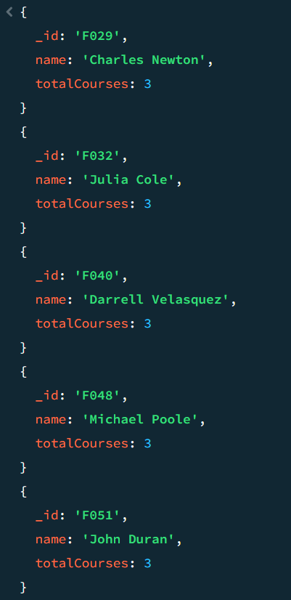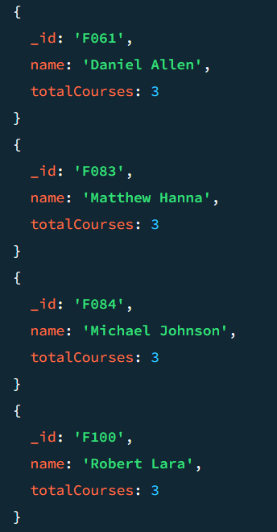

2. Joins ($lookup) and Aggregations
Q3. Write a query to show each student’s name along with the course titles they are enrolled in
(use $lookup between enrollments, students, and courses).
Query:
db.enrollments_full.aggregate([
// Step 1: join with students
{
$lookup: {
from: "students_full",
localField: "student_id",
foreignField: "_id",
as: "student"
} },
// Step 2: join with courses
{
$lookup: {
from: "courses_full",
localField: "course_id",
foreignField: "_id",
as: "course"
} },
// Step 3: flatten arrays
{ $unwind: "$student" },
{ $unwind: "$course" },
// Step 4: final output
{
$project: {
_id: 0,
student_name: "$student.name",
course_title: "$course.title"
}}])
Output:
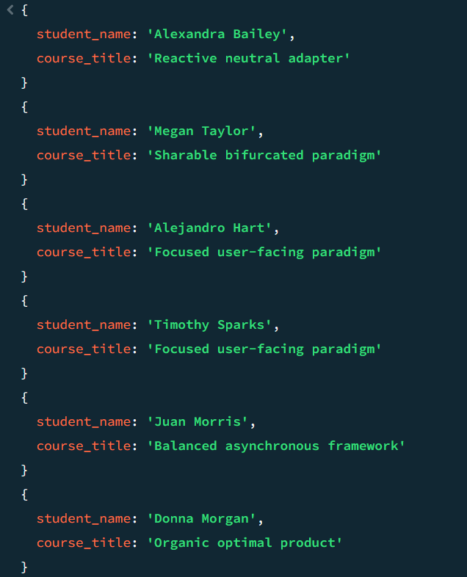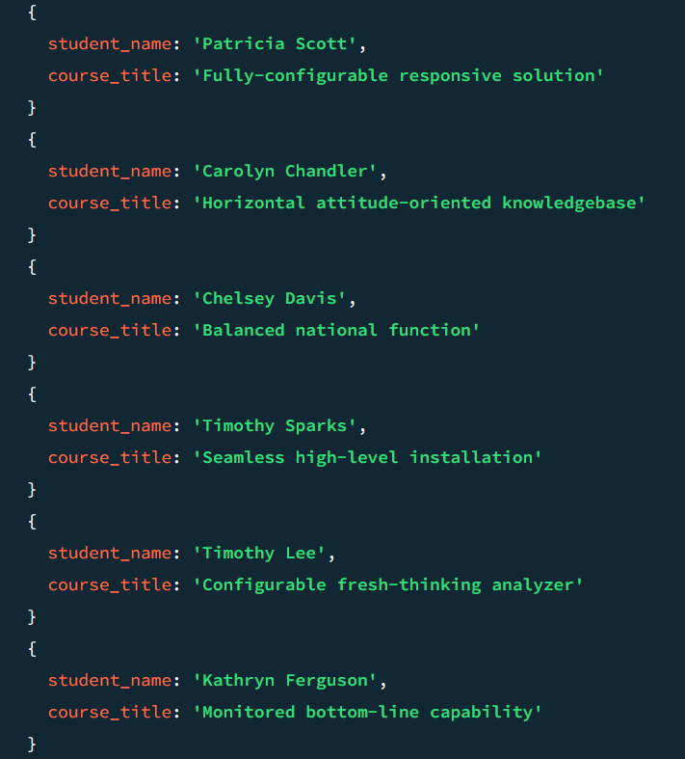

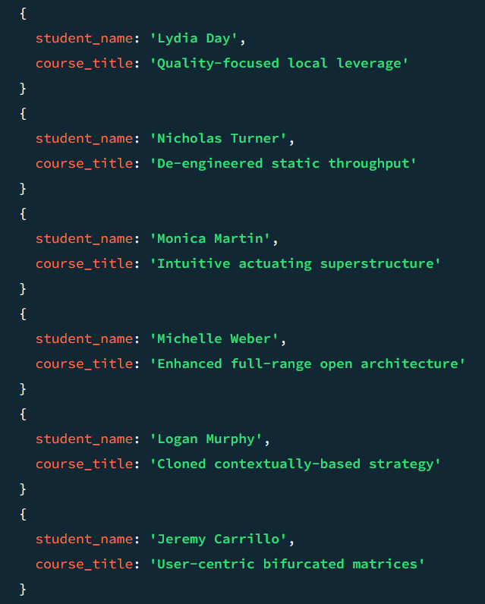
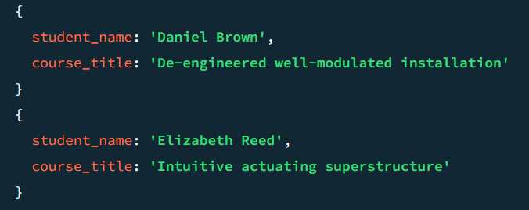

Q4. For each course, display the course title, number of students enrolled, and average marks
(use $group).
Query:
db.enrollments_full.aggregate([
// Step 1: group by course
{
$group: {
_id: "$course_id",
totalStudents: { $sum: 1 },
avgMarks: { $avg: "$marks" }
}},
// Step 2: join with courses
{ $lookup: {
from: "courses_full",
localField: "_id",
foreignField: "_id",
as: "course"
} },
// Step 3: flatten
{ $unwind: "$course" },
// Step 4: final output
{
$project: {
_id: 0,
course_title: "$course.title",
totalStudents: 1,
avgMarks: { $round: ["$avgMarks", 2] }
}}])
Output:
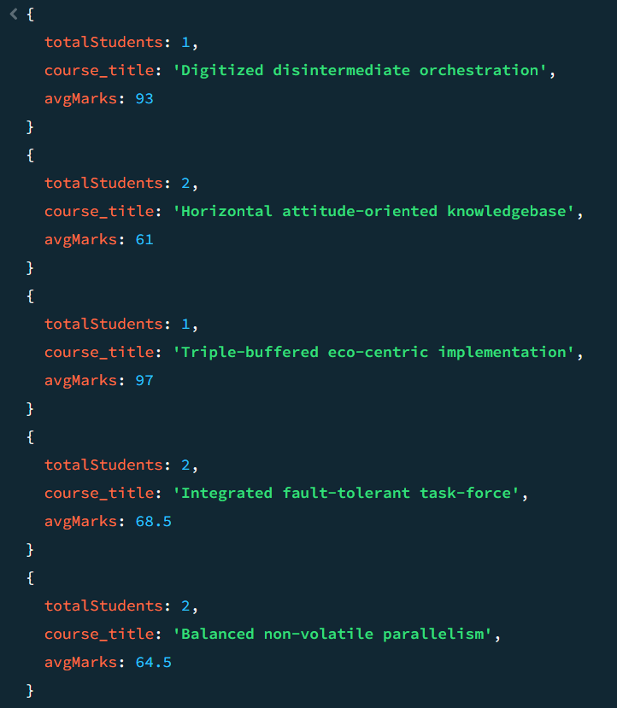
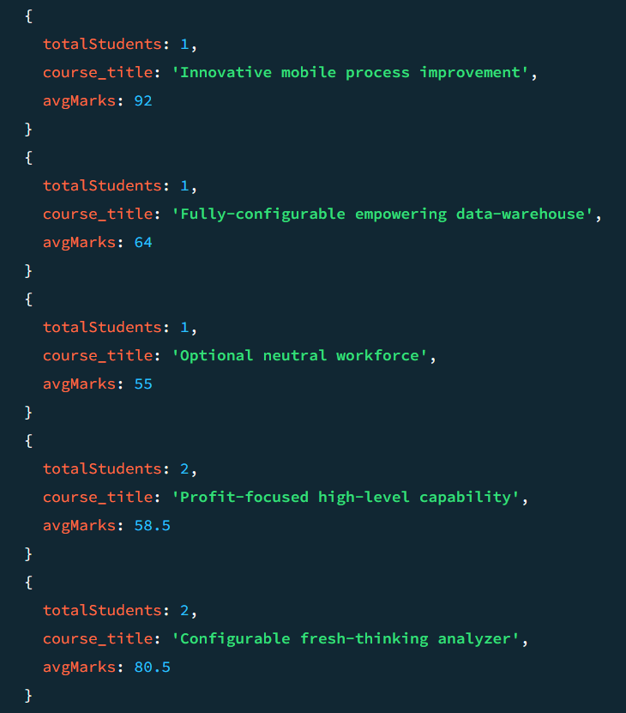
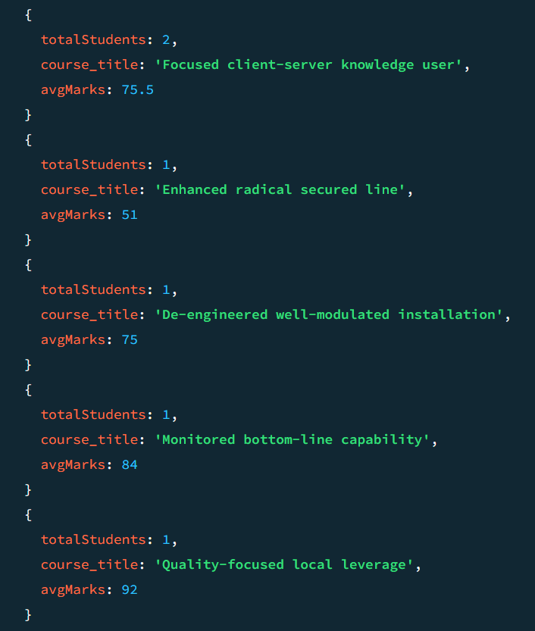
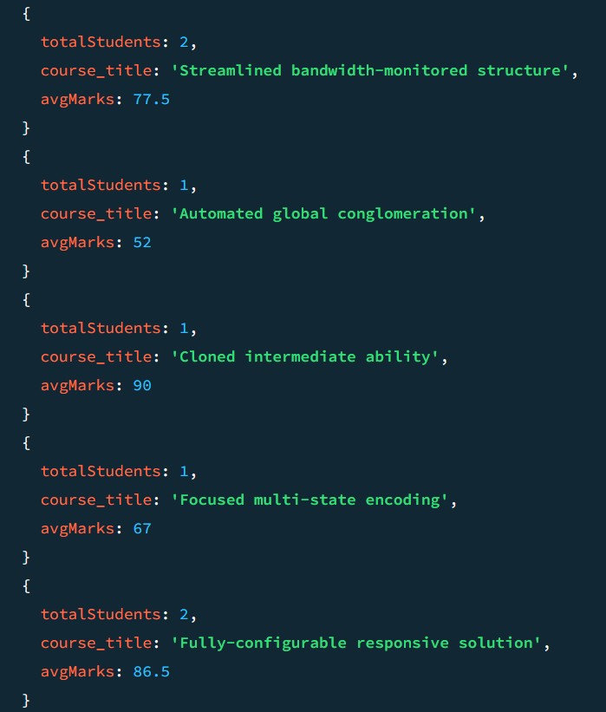

3. Grouping, Sorting, and Limiting
Q5. Find the top 3 students with the highest average marks across all enrolled courses.
Query:
db.enrollments_full.aggregate([
// Step 1: group by student
{
$group: {
_id: "$student_id",
avgMarks: { $avg: "$marks" }
} },
// Step 2: sort highest first
{
$sort: { avgMarks: -1 } },
// Step 3: limit top 3
{
$limit: 3
},
// Step 4: join with students to get name
{
$lookup: {
from: "students_full",
localField: "_id",
foreignField: "_id",
as: "student"
} },
{ $unwind: "$student" },
// Step 5: final output
{
$project: {
_id: 0,
student_name: "$student.name",
avgMarks: { $round: ["$avgMarks", 2] }
} }])
Output:
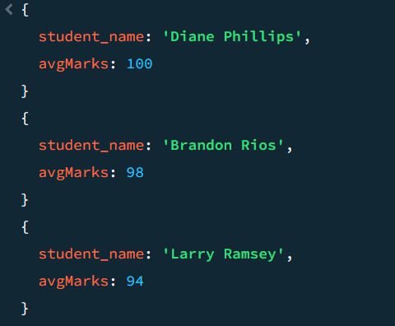

Q6. Count how many students are in each department. Display the department with the highest
number of students.
Query:
db.students_full.aggregate([
// Step 1: group by department
{
$group: {
_id: "$department",
totalStudents: { $sum: 1 }
}},
// Step 2: sort descending
{
$sort: { totalStudents: -1 }
},
// Step 3: top department
{
$limit: 1
},
// Step 4: format output
{
$project: {
_id: 0,
department: "$_id",
totalStudents: 1
}}])
Output:
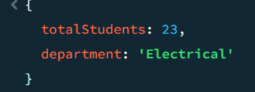
4. Update, Upsert, and Delete
Q7. Update attendance to 100% for all students who won any "Hackathon".
Query:
db.students_full.updateMany(
{
_id: {
$in: db.activities_full.distinct("id", {
title: "Hackathon"
})} },
{
$set: { attendance: 100 }
})
Output:
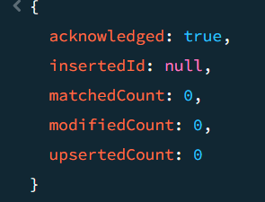
Q8. Delete all student activity records where the activity year is before 2022.
Query:
db.activities_full.deleteMany({
year: { $lt: 2022 }
})
Output:
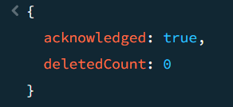
Q9. Upsert a course record for "Data Structures" with ID "C150" and credits 4—if it
doesn’t exist, insert it; otherwise update its title to "Advanced Data Structures".
Query:
db.courses_full.updateOne(
{ _id: "C150" },
{
$set: {
title: "Advanced Data Structures",
credits: 4
} },
{ upsert: true })
Output:
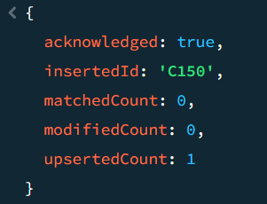

5. Array & Operator Usage
Q10. Find all students who have "Python" as a skill but not "C++".
Query:
db.students_full.find(
{
skills: {
$all: ["Python"], // Python
$nin: ["C++"] // C++
} },
{
name: 1,
skills: 1,
_id: 0
})
Output: 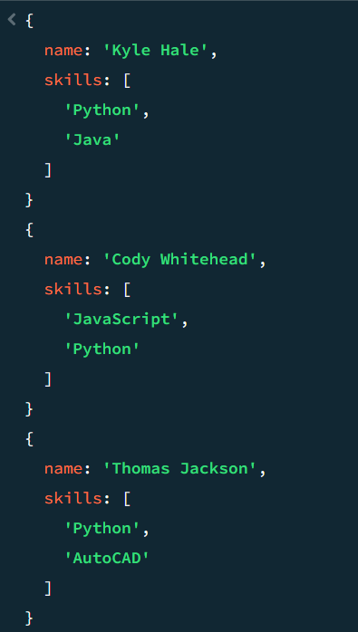 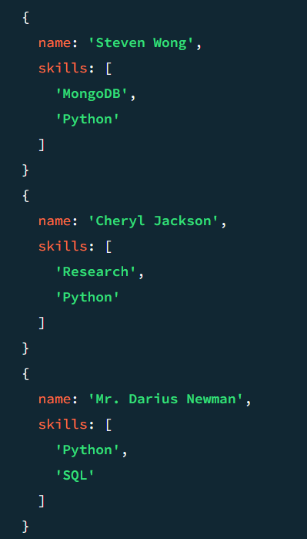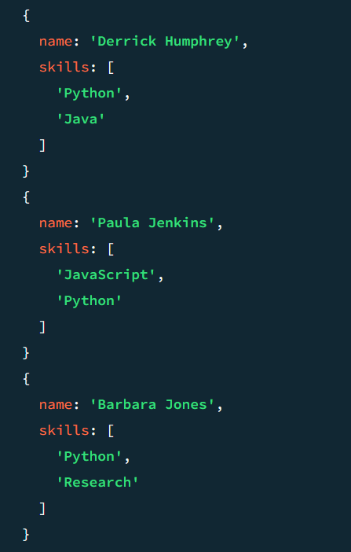 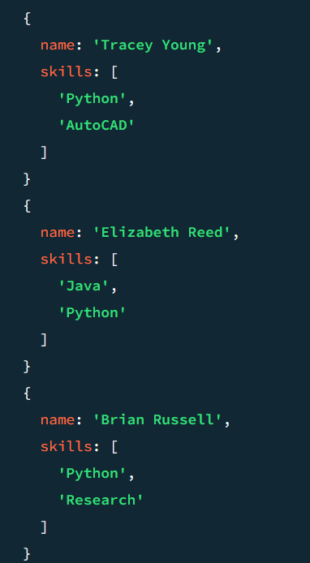
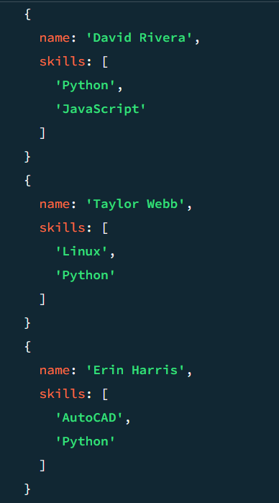

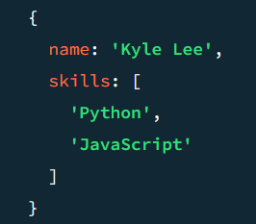

Q11. Return names of students who participated in "Seminar" and "Hackathon" both.
Query:
db.activities_full.aggregate([
// Step 1: filter Seminar & Hackathon
{
$match: {
type: { $in: ["Seminar", "Hackathon"] }
} },
// Step 2: group by student
{
$group: {
_id: "$student_id",
activities: { $addToSet: "$type" }
} },
// Step 3: ensure both present
{
$match: {
activities: { $all: ["Seminar", "Hackathon"] }
} },
// Step 4: join with students
{
$lookup: {
from: "students_full",
localField: "_id",
foreignField: "_id",
as: "student"
} },
{ $unwind: "$student" },

// Step 5: output
{
$project: {
_id: 0,
student_name: "$student.name"
}}])
Output:
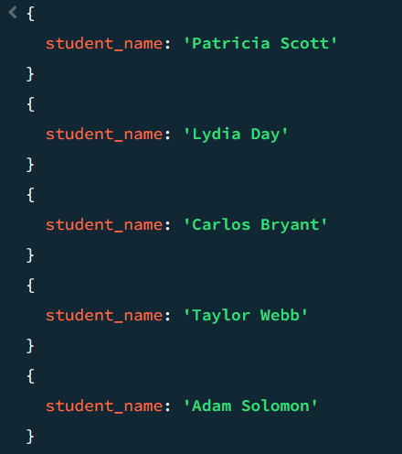

6. Subdocuments and Nested conditions
Q12. find the students who scored more than 80 in "web development" only if they belong to the "computer science" department
Query:
db.enrollments.aggregate([
{
$lookup: {
from: "students",
localField: "student_id",
foreignField: "_id",
as: "student"
}
},
{
$lookup: {
from: "courses",
localField: "course_id",
foreignField: "_id",
as: "course"
}
},
{
$unwind: "$student"
},
{
$unwind: "$course"
},
{
$match: {
"student.department": "Computer Science",
"course.title": /web development/i,
"marks": { $gt: 80 }
}
},
{
$project: {
_id: 0,
student_name: "$student.name",
department: "$student.department",
course: "$course.title",
marks: 1
}
}
])
Output:
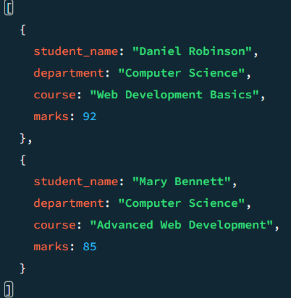

7. Advanced Aggregation:
Q13. For each faculty member, list the names of all student enrolled in their courses along with average marks per student per faculty.
Query:
db.faculty.aggregate([
{
$lookup: {
from: "courses",
localField: "_id",
foreignField: "faculty_id",
as: "courses"
}
},
{
$unwind: "$courses"
},
{
$lookup: {
from: "enrollments",
localField: "courses._id",
foreignField: "course_id",
as: "enrollments"
}
},
{
$unwind: "$enrollments"
},
{
$lookup: {
from: "students",
localField: "enrollments.student_id",
foreignField: "_id",
as: "student"
}
},
{
$unwind: "$student"
},
{
$group: {
_id: {
faculty_id: "$_id",
faculty_name: "$name",
student_id: "$student._id",
student_name: "$student.name"
},
avgMarks: { $avg: "$enrollments.marks" }
}
},
{
$group: {
_id: {
faculty_id: "$_id.faculty_id",
faculty_name: "$_id.faculty_name"
},
students: {
$push: {
student_name: "$_id.student_name",
avgMarks: { $round: ["$avgMarks", 2] }
}
}
}
},
{
$project: {
_id: 0,
faculty_id: "$_id.faculty_id",
faculty_name: "$_id.faculty_name",
students: 1
}
}
])
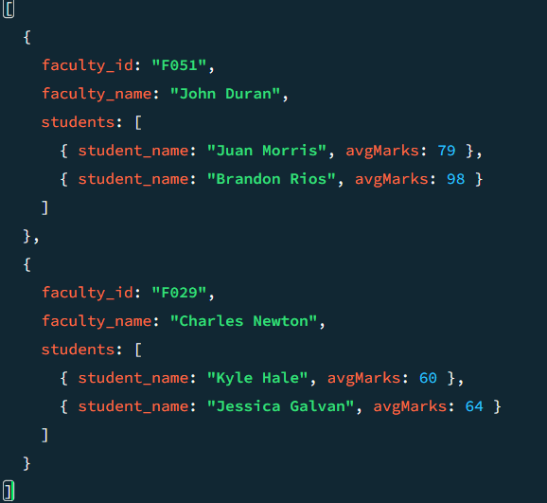
Output:

Q14. Show the most popular activity type (e.g., Hackathon, Seminar, etc.) by number of student participants.
Query:
db.activities.aggregate([
{
$group: {
_id: "$type",
totalParticipants: { $sum: 1 }
}
},
{
$sort: { totalParticipants: -1 }
},
{
$limit: 1
},
{
$project: {
_id: 0,
activity_type: "$_id",
totalParticipants: 1
}
}
])

Output:
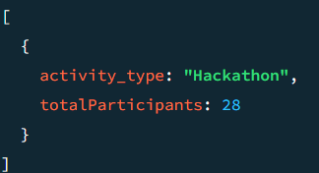

Name: Mannat Mishra
Roll No: 1250259032
Batch: MCADS11

